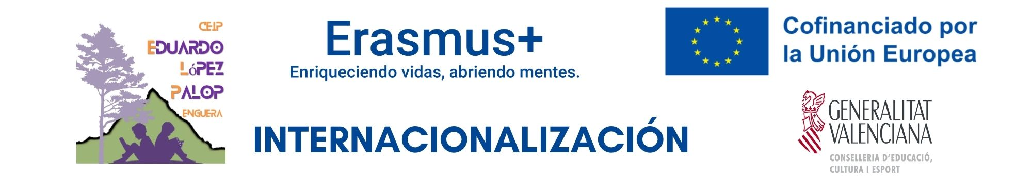
The CEIP Eduardo López Palop is organized into two educational stages:
- INFANTIL: Early years education (ages 2–6)
- PRIMARIA: Primary education (ages 6–12)

During the week of the 19th to 23rd october, teachers from two different countries—Coacia and Gemany—will be visiting us. Sometimes, they will take part in activities, and other times they will observe lessons based on their areas of interest. The timetable is always flexible and it can be adapted.

Areas of focus:
Hands-on Maths using OAOA + STEAM methodology
Teaching Arts in English
Environmental care: recycling + composting + vegetable garden
Inclusion
Early years: 'learning environments’ on Fridays.

On 20th Tuesday, we will celebrate Erasmus Day with all the pupils at the school, with several workshops in the school playground.

Friday - ENVIRONMENTS:
1- STORY: Dramatization of a story related to spring.
2- ART: Painting workshops and other creative activities using recycled materials.
3- FINE MOTOR SKILLS: Hands-on activities using everyday materials (water, flour, etc.)
4- BLACKLIGHT: Spring-themed games and art activities in a different setting.
5- LOGIC AND MATHEMATICS: Maths workshops through experimentation.
6- PHONOLOGICAL AWARENESS: Games involving oral expression and movement in order to develop language skills.

We will also have time to:
• Learn about Spanish school culture and the education system
• Exchange professional views with teachers from different countries
• Strengthen cooperation and documentation within the framework of Erasmus+

Schedule

 | Croatian team | Croatian team + German team
 | MONDAY | TUESDAY | WEDNESDAY | THURSDAY | FRIDAY
9:00h | Welcome | Educational System  Teacher: Maite | Educational and Cultural Visits  • Visit to  IES Enguera (secondary school)  • Visit to Cultural house  • Visit the local museums.  • Visit to the library.  Introduction to educational and cultural resources available in the local community. | 3rd Grade: Maths  Teacher: M.ª Carmen | 2nd Grade: STEAM . Teachers: Patri and Robert
9:45h | Manipulative Mathematics – 2nd Grade - Teachers: Patri and Irene | Educational System  Teacher: Maite |  | 3rd Grade: Maths  Teacher: M.ª Carmen | Kindergarden:  learning environments
10:25h |  | Educational System  Teacher: Maite |  | ADISPEC  +  Campoenguera  ADISPEC, a centre for people with different abilities.  Campoenguera to learn about the local olive-oil production process and its connection with the local economy and environment. | Kindergarden:  learning environments
10:25h |  | Coffee break |  |  | Kindergarden:  learning environments
11:0oh | Coffe break | Erasmus Day Workshops |  |  | Kindergarden:  learning environments
 |  |  |  |  | Coffee break
12:00h | Kindergarden - Teachers: Laura, Lorena, Nieves, Amparo | Inclusion – 4th Grade -  Teacher: Estela |  |  | Compost workshop
Final reflection and evaluation.

Reflection on the job-shadowing experience.
Discussion of the main learning outcomes.
Exchange of ideas for future cooperation between schools.
12:40h | Kindergarden - Teachers: Laura, Lorena, Nieves, Amparo | 6th Grade – Observation/ participation English language lessons  Teacher: Robert
13:20h | 5th Grade – Classroom Observation - Teacher: Trini
14:00h | Lunch | TEACHERS PHOTO.  Lunch | Lunch | Lunch | Lunch
 |  |  | 17:00h  Cultural Visit: Anna Palace – Teachers Amparo and Trini. | Cultural Visit to Xàtiva  (Robert and Laura)

Dear guests,
We are truly delighted to welcome you to our school. It is a genuine pleasure to have you with us. We know that starting in a new country can be both an exciting and challenging experience, and we want you to know that you are not alone on this journey.
We are here to support, help, and accompany you in whatever you may need. Our greatest wish is for you to feel part of this community from the very first moment, and for this school to become your home as well.
Our teachers and all our students are excited to share our culture with you, to learn together, and to enjoy new experiences that will enrich us all. We are confident that, step by step, we will build a journey full of learning, respect, and friendship together.
With all our affection, we warmly welcome you from the entire educational community.
